AREDN on Proxmox

December, 18th 2023

German Video of Webinar on this channel: https://www.youtube.com/@uskapr113

Inhalt

System Overview 3

Needed Steps 4

Proxmox installation 5

VLAN enabling of the Proxmox network 6

VLAN definition for this document 6

Create an AREDN VM (Tunnel or Telephone Server) 7

Creating the VM 7

Configuring the AREDN VM 10

Setting Up the AREDN Disk 11

Create a Debian VM as a Management Console 15

Create a Management Console in an LXC Container (work in progress, not finished) 24

Create a Container using a Debian image 24

Create a new user 24

Configure the AREDN Tunnel Server 25

Initial setup of the AREDN router 25

Connection to the configured Tunnel Server (incl. ssh) 26

Network mapping inside the AREDN VM 28

Backup of the VM 30

Install QUEMU Agent 31

AREDN Virtual Machine as a Telephone Server 34

Overview 34

Setup 34

Final tip: 36

# System Overview

This is the setup we want to achieve:



# Needed Steps

1. Install Proxmox on an X.86 machine (PC)
2. Adjust network of the node
3. Create an AREDN VM
4. Create a Debian VM (or any other distribution that can run a terminal and a browser)
5. Connect to AREDN from Debian to setup the network configuration as well as the AREDN node

# Proxmox installation

You find many tutorials to install Proxmox on an X86 machine.

Find the IP address of your Proxmox server (using Advanced IP Scanner)

Open a web browser and navigate to the Proxmox web UI (e.g. https://192.168.0.230:8006/

# VLAN enabling of the Proxmox network

Navigate to pve8🡪Network

vmbr0 is the same as port 1 on the hap router and is connected to the internet (for tunnels) It is default on Proxmox.

Make vmbr0 VLAN aware:

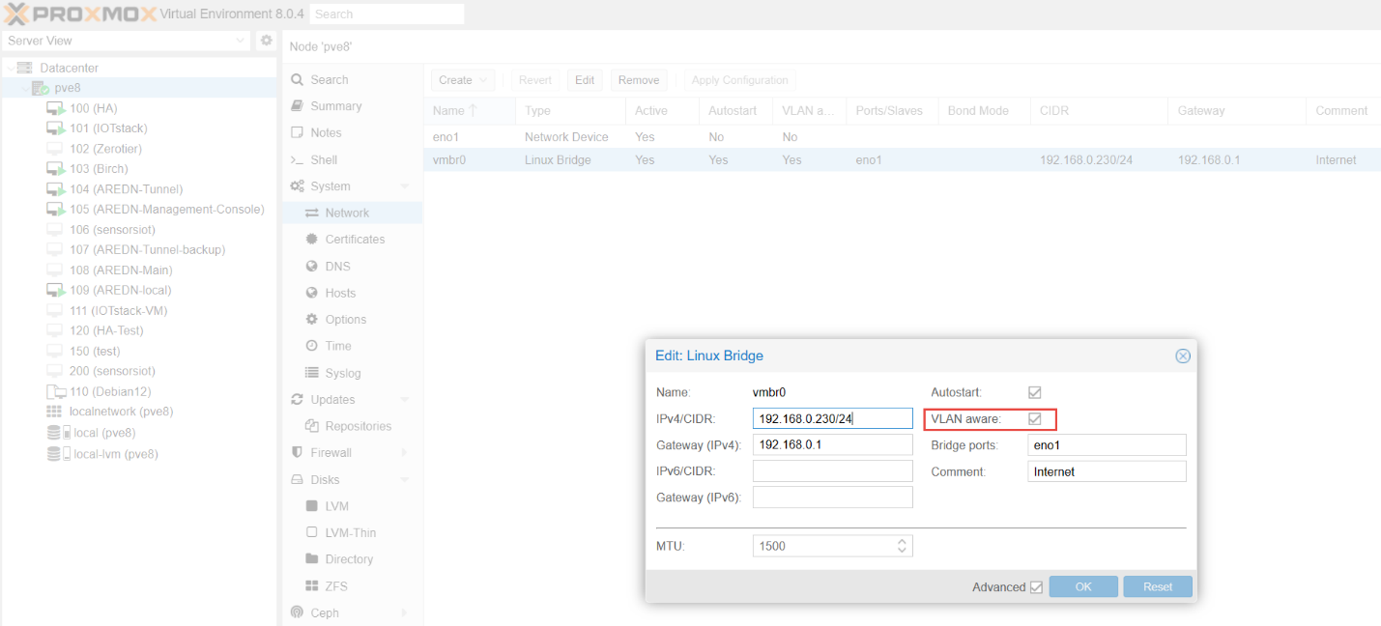

## VLAN definition for this document

VLAN1: Used as “untagged” VLAN by AREDN

VLAN2: Used for Device-to-Device (DtD) communication by AREDN

VLAN10: Used as LAN network for the Tunnel Server (by the author, can be changed)

VLAN20: Used as LAN network for the Telephone Server (by the author, can be changed)

# Create an AREDN VM (Tunnel or Telephone Server)

Based on: <https://i12bretro.github.io/tutorials/0405.html>

and

<https://youtu.be/8nsdrWeeg8o>

## Creating the VM

Click the Create VM button at the top right:



And fill in a name and an ID for your VM (start at boot not ticked):

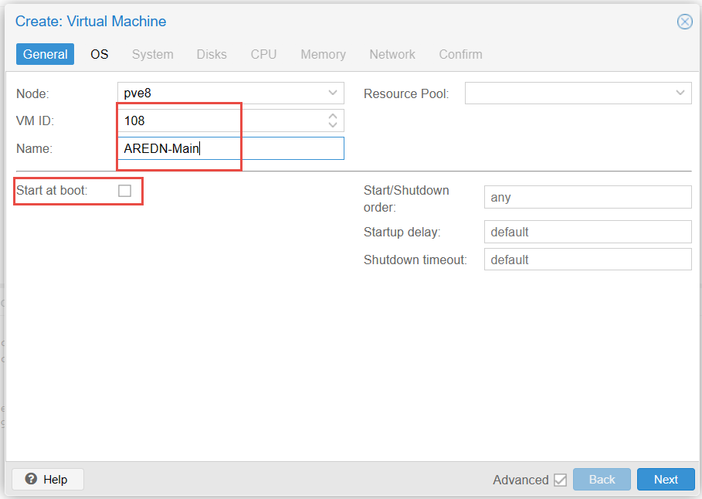

Start at boot can be ticked when everything works

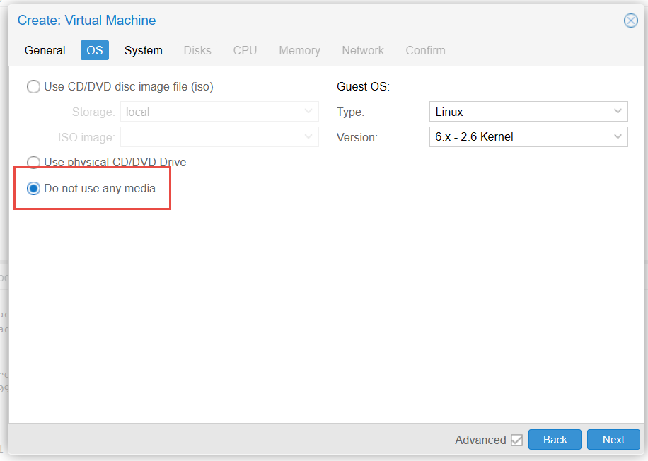

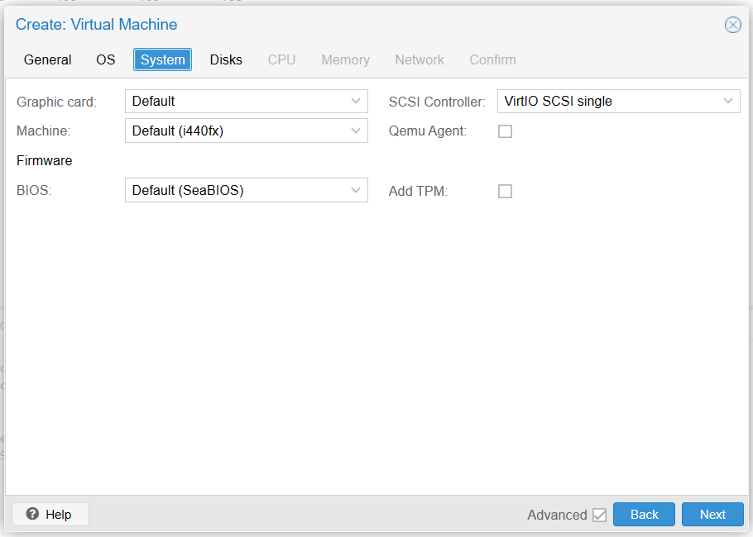

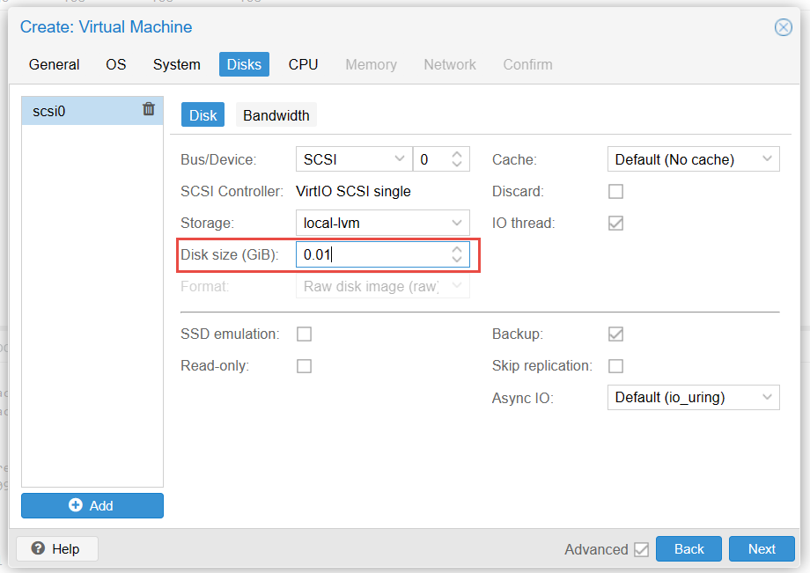

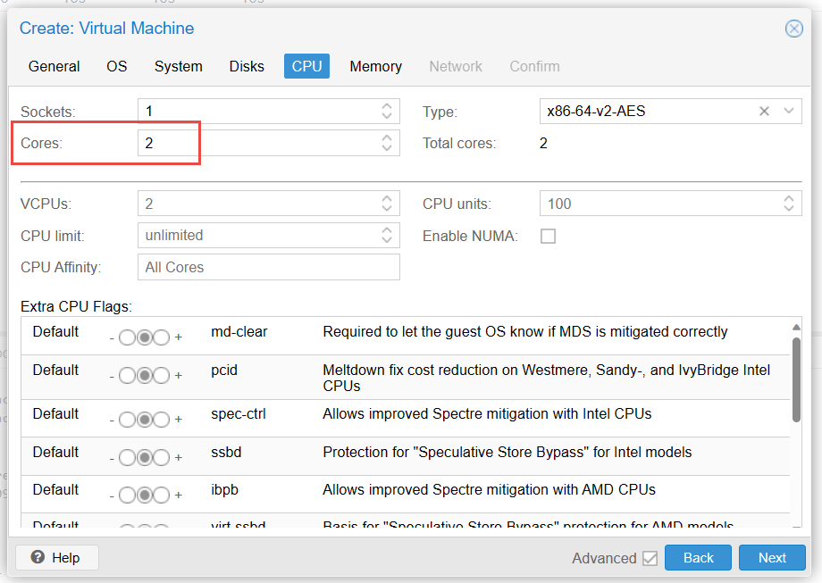

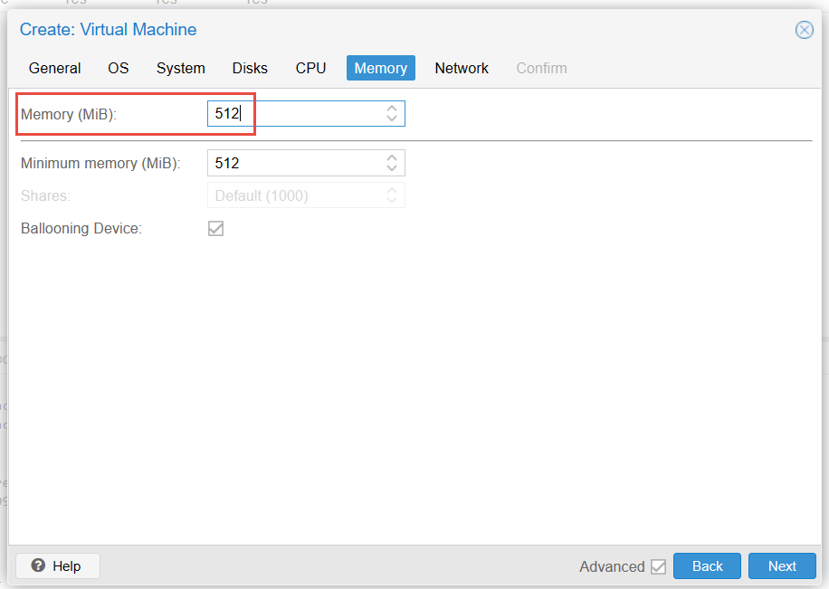

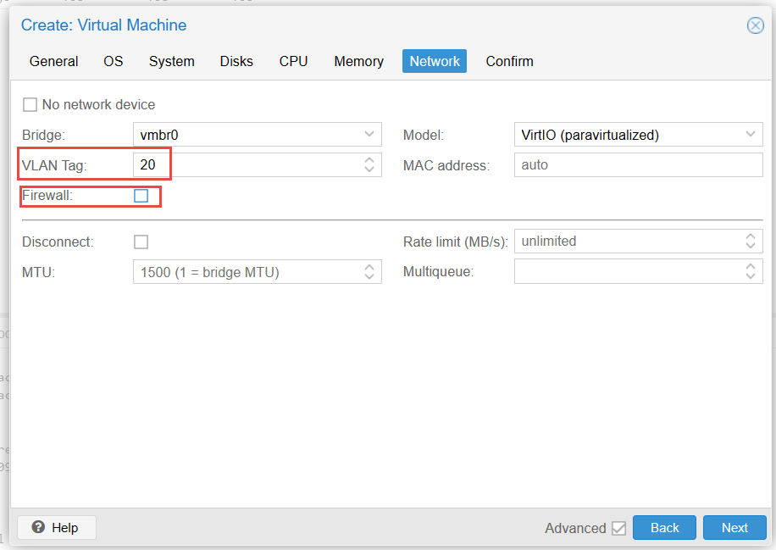

Add VLAN 20 (to prevent DHCP server interacting with your home network (and untick firewall):

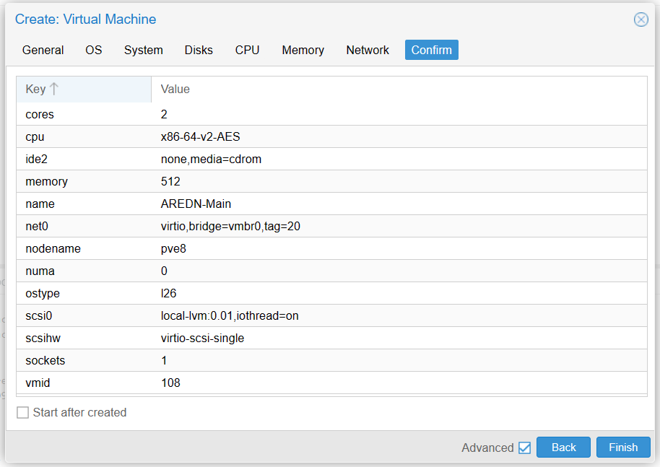

Confirm the summary and wait till the VM is created

## Configuring the AREDN VM

Change VLAN tag and remove firewall of Network device (net0) to create LAN port

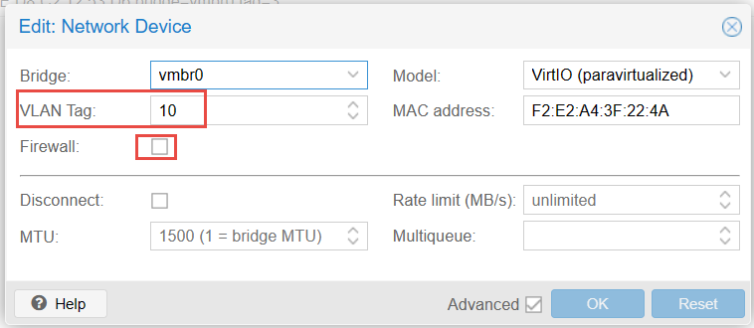

VLAN 10 (or any other above 10) is used to insulate the DHCP server of the AREDN node. If you forget it, you can shut down your whole home network when you start the server!

Click the Add button > Network Device

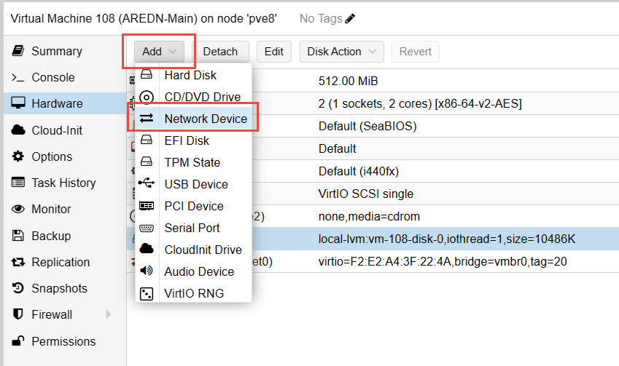

to create the WAN port

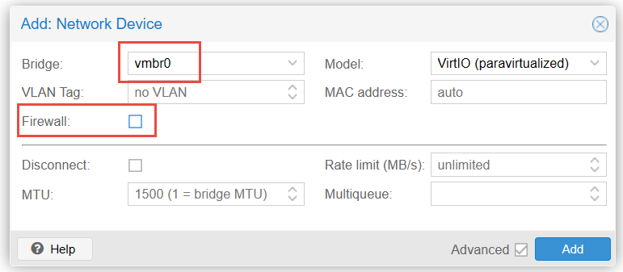

Add the DtD interface in VLAN2

Ein Bild, das Text, Schrift, Zahl, Reihe enthält.

The result should look like that:

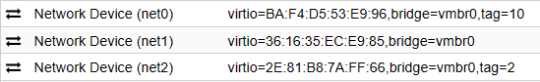

And finally, detach and remove harddisk (scsi0)

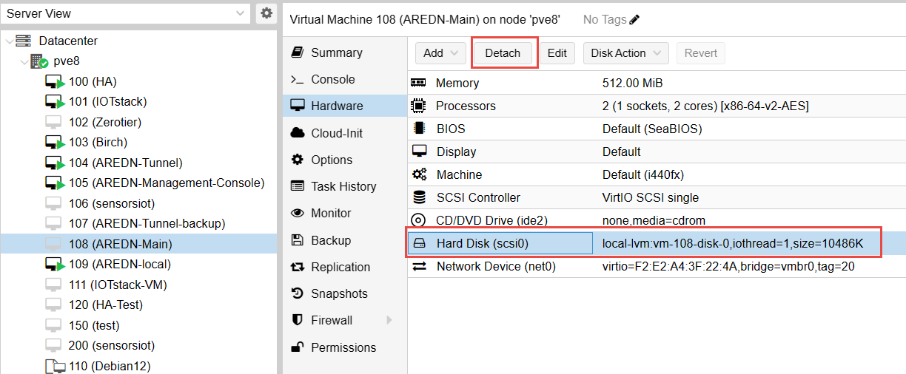

## Setting Up the AREDN Disk

Go to the shell of the server and download the image

Ein Bild, das Text, Screenshot, Software, Computersymbol enthält.

wget -O aredn.img.gz http://downloads.arednmesh.org/releases/3/23/3.23.12.0/targets/x86/64/aredn-3.23.12.0-x86-64-generic-ext4-combined-efi.img.gz

Adjust the release if you want. Or upgrade your VM later using the AREDN VM

extract the AREDN img

gunzip ./aredn.img.gz

rename the extracted img

mv ./aredn*.img ./aredn.raw

increase the raw disk to 512 MB

qemu-img resize -f raw ./aredn.raw 512M

import the disk to the openwrt VM (replace 104 with your VM number)

qm importdisk 104 /root/aredn.raw local-lvm

The disk is now visible as “Unused Disk 0”. Add the disk (double click on it) to your VM:

Ein Bild, das Text, Software, Zahl, Screenshot enthält.

Change boot order:

Ein Bild, das Text, Screenshot, Software, Zahl enthält.

Double click Use tablet pointer > Uncheck the Enabled box > Click OK

Ein Bild, das Text, Zahl, Schrift, Software enthält.

Go to Console and press “Start Now”

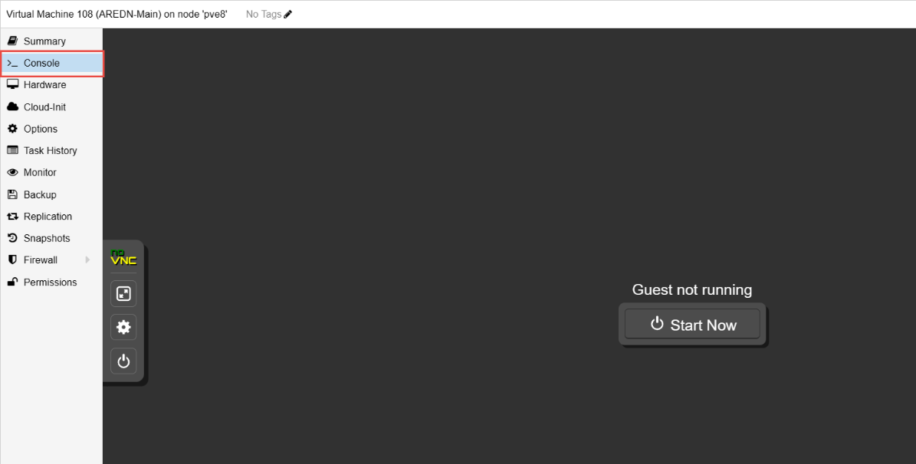

Watch the boot process, wait for the text to stop scrolling and press “Enter”

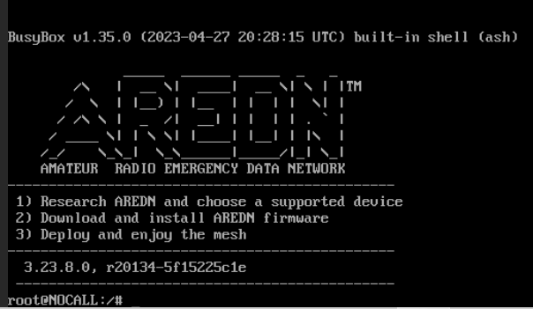

Run the following command to change/set the root password

passwd

Type a new root password twice. Attention: It is a US keyboard (Y/Z)

For the moment we are done with the AREDN node. Because we had to separate the LAN from our home network, we only can manage the node in the Proxmox terminal (it does not offer a browser). To solve the problem, we add a VM with plain vanilla Debian and connect it to VLAN20, too. Like that we have a private connection to manage our AREDN node.

Of course, you can use any other VM that offers a browser and is connected to vmbr0/VLAN10.

Type

ip addr

To check the address of your VM. It should be 192.168.1.1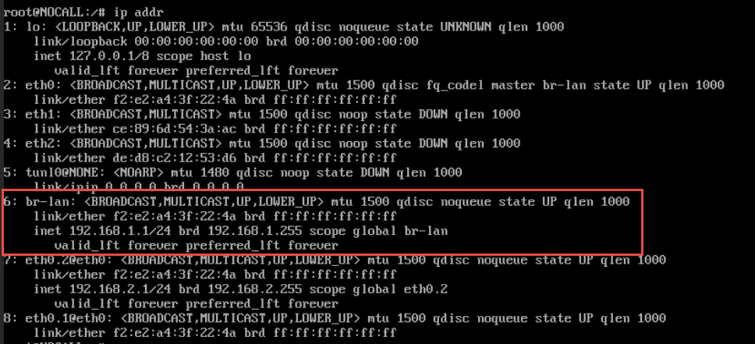

# Create a Debian VM as a Management Console

<https://youtu.be/OUC7DMBfR3Y?si=y4r3edcwzzpd2JHJ>

Download the Debian 11 iso Download

<https://cdimage.debian.org/debian-cd/current/amd64/iso-cd/> (debian-12.1.0-amd64-netinst.iso)

Ein Bild, das Text, Screenshot, Software, Computersymbol enthält.

Create VM

Ein Bild, das Text, Screenshot, Software, Display enthält.

On the OS tab,

Ein Bild, das Text, Screenshot, Software, Display enthält.

Leave the defaults on the System tab

Ein Bild, das Text, Screenshot, Display, Software enthält.

On the Hard Disk tab, set the Disk size to 16 GiB or more

Ein Bild, das Text, Screenshot, Software, Display enthält.

On the CPU tab

Ein Bild, das Text, Screenshot, Display, Software enthält.
,

On the Memory tab

Ein Bild, das Text, Screenshot, Display, Software enthält.

Network tab: Add the VLAN number of the LAN port of the AREDN server you want to connect to and untick the firewall.

Edit: Do not add the VLAN right now. Add it when you are finished with the installation and want to connect to an AREDN node. Otherwise you will not be able to continue.

Ein Bild, das Text, Screenshot, Display, Software enthält.

Verify the summary and click Finish

Start the VM

Ein Bild, das Text, Software, Multimedia-Software, Computersymbol enthält.

Graphical Install

Ein Bild, das Text, Screenshot, Schrift, Design enthält.

Select a language

Ein Bild, das Text, Screenshot, Display, Software enthält.

Select a Location (other 🡪Europe🡪Switzerland)

Ein Bild, das Text, Screenshot, Software, Display enthält.

Select locales (can be adapted later)

Ein Bild, das Text, Screenshot, Display, Software enthält.

Select a keyboard layout (can be changed later)

Ein Bild, das Text, Screenshot, Display, Software enthält.

Enter a hostname for the VM

Ein Bild, das Text, Screenshot, Display, Software enthält.

Leave domain name empty

Ein Bild, das Text, Schrift, Reihe, Screenshot enthält.

Leave root password empty

Ein Bild, das Text, Reihe, Schrift, Zahl enthält.

Enter the full name for the new user

Ein Bild, das Text, Schrift, Screenshot, Reihe enthält.

Enter the username for the new user

Ein Bild, das Text, Schrift, Reihe, Screenshot enthält.

Enter and confirm a password for the new user

Ein Bild, das Text, Reihe, Schrift, Zahl enthält.

Select Disk

Ein Bild, das Text, Schrift, Reihe, Screenshot enthält.

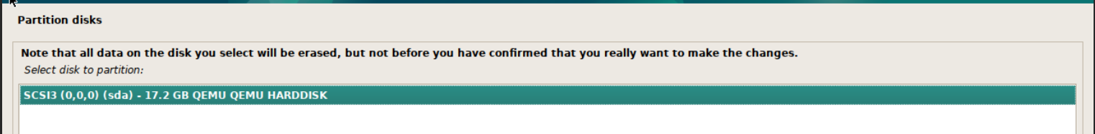

Ein Bild, das Text, Schrift, Screenshot enthält.

Check and click Continue

Ein Bild, das Text, Screenshot, Software, Webseite enthält.

Select Yes to confirm writing the changes

Ein Bild, das Text, Screenshot, Schrift, Software enthält.

Wait for Debian to copy and install files

Ein Bild, das Text, Screenshot, Schrift enthält.

Ein Bild, das Text, Screenshot, Display, Software enthält.

Ein Bild, das Text, Schrift, Screenshot enthält.

Ein Bild, das Text, Schrift, Reihe, Screenshot enthält.

Wait

Participating in package survey

Ein Bild, das Text, Schrift, Screenshot enthält.

Select the software to install

Ein Bild, das Text, Software, Screenshot, Webseite enthält.

Select (tick) “SSH server”

Wait

Select Yes to install GRUB

Ein Bild, das Text, Schrift, Screenshot enthält.

Select drive for the boot loader

Ein Bild, das Text, Schrift, Screenshot enthält.

Reboot

Remove CD drive (it will only be removed after reboot)

Ein Bild, das Text, Screenshot, Zahl, Schrift enthält.

Go to the Console and login

Ein Bild, das Screenshot, Schwarz, Schwarzweiß enthält.

Start Firefox. On <http://localnode.local.mesh> you should see your AREDN server on the same VLAN because your Management Console is connected via the vmbr0/10 interface.

# Create a Management Console in an LXC Container (work in progress, not finished)

## Create a Container using a Debian image

## Create a new user

apt install sudo curl -y

adduser aredn

usermod -aG sudo aredn

exit

Logout and login with new user

Check if it worked:

sudo apt update

sudo apt install xrdp -y

sudo echo xfce4-session >~/.xsession

sudo nano /etc/xrdp/startwm.sh

add

startxfce4

at the end of the file

# Configure the AREDN Tunnel Server

Because our Management Console VM is connected to our AREDN VM via vmbr0/VLAN10 it should get an IP.

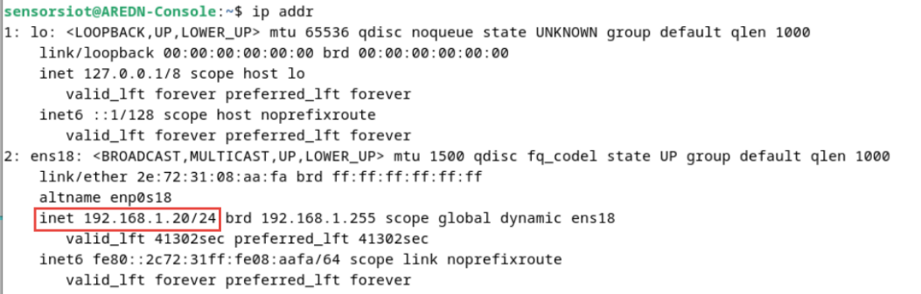

To check the connection, you can ping the AREDN VM:

ping localnode.local.mesh

## Initial setup of the AREDN router

Open the browser and call localnode.local.mesh

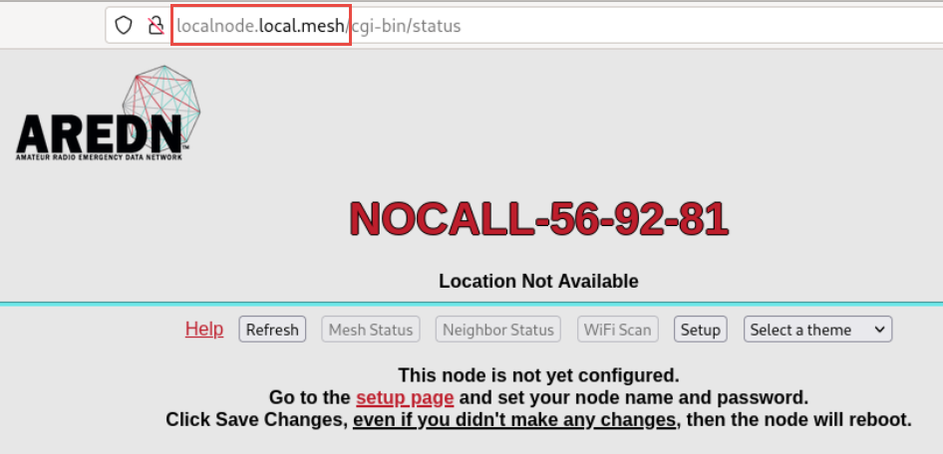

Press setup (password: “hsmm” or your password given above)

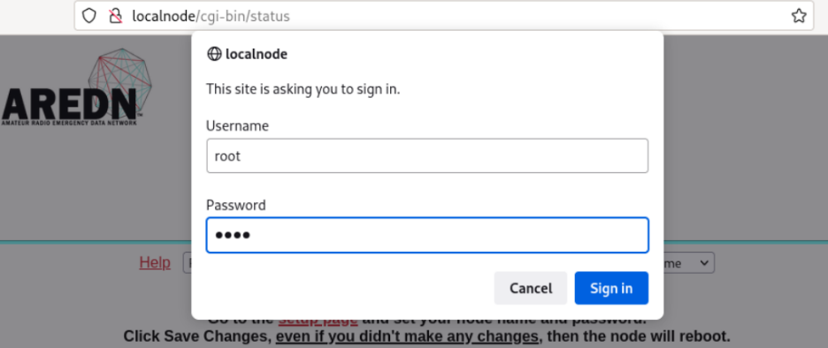

Give it a name and a password, hit “Save changes” and “reboot”

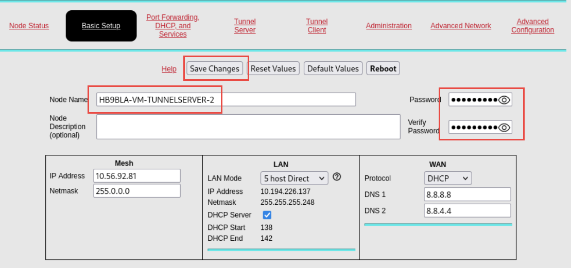

After reboot, your AREDN VM should have an 10.x.x.x address

If the Management Console does not connect to the AREDN VM, it still has its old address.

So type these two commands to get a new address from the AREDN VM:

sudo dhclient -r

sudo dhclient

From now on, you can manage your AREDN node from the Management Console

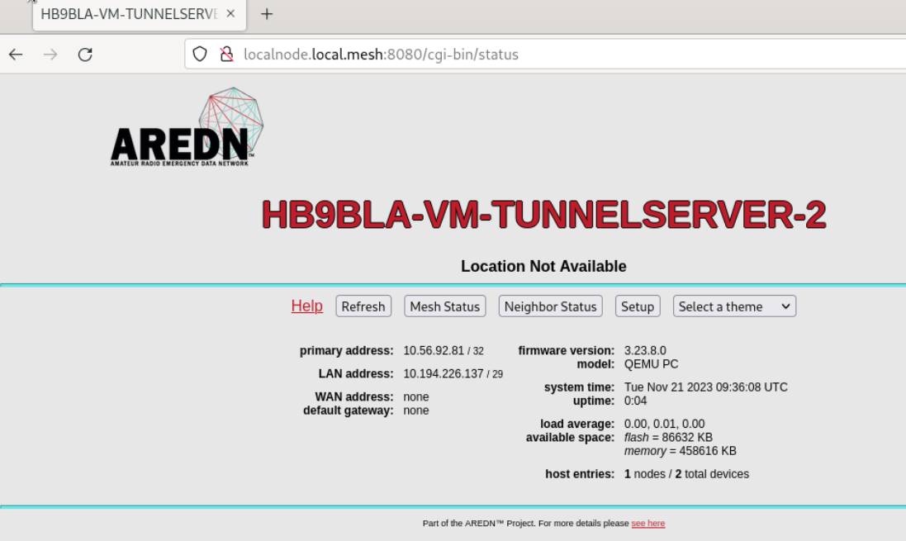

### Connection to the configured Tunnel Server (incl. ssh)

Connect again to your AREDN server (unfortunately, Proxmox does not allow copy-paste):

Ein Bild, das Text, Screenshot, Schrift, Zahl enthält.

Press yes, and enter the password **hsmm**

If you get a “man in the middle” warning, key in the suggested command:

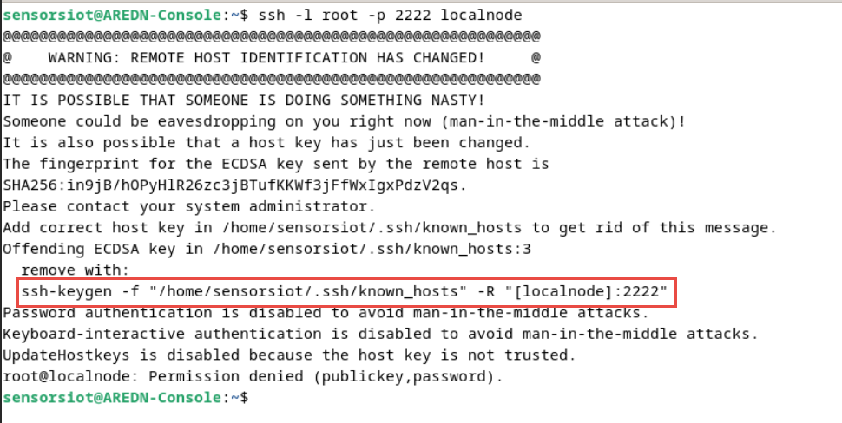

This is the correct answer:

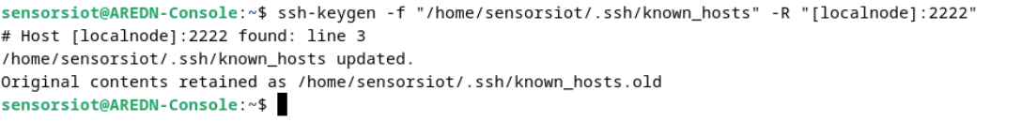

Now you can try to ssh into your server as before

Ein Bild, das Text, Elektronik, Screenshot, Display enthält.

### Network mapping inside the AREDN VM

In the end we would like the following mapping:



The mapping of the nets has to be done now in the terminal of the Management Console.

Type:

vi /etc/config/network

and hit the “insert” key.

Leave the Wi-Fi configuration as it is:

Ein Bild, das Text, Screenshot, Schrift, Dokument enthält.

Add two ports to the bridge configuration:

Ein Bild, das Text, Schrift, weiß, Screenshot enthält.

Adjust the LAN configuration:

Ein Bild, das Text, Screenshot, Schrift, Zahl enthält.

The LAN is connected to eth0 that is net0 in Proxmox on VLAN 20. Only our Management Console is connected to this network. So the DHCP server inside the AREDN server is insulated and does not harm your home network.

The WAN port has to be connected to the internet. Vmbr0 is connected to the RJ45 connector of your server. It uses the general purpose VLAN 1 and will get a DHCP address from your home network.

Ein Bild, das Text, Screenshot, Schrift enthält.

The DtD (device-to-device) port is connected to the RJ45 of your Proxmox server via vmbr0, but this time using VLAN 2. To avoid problems with the DHCP server of other AREDN devices like the hap routers, we have to add a managed switch where we only transfer VLAN 2 to the ports where we connect port 5 of the hap routers or any “antennas”.

Ein Bild, das Text, Screenshot, Schrift enthält.

All networks have to marked “untagged” (e.g. “eth2:u”). They are tagged by Proxmox. And Proxmox does not like tagged stuff from the container.

The rest of the configuration file is only comments and is not changed for the moment.

Press the “escape” button and “:wq” to save your changes.

Reboot.

## Make the configuration surviving changes and reboots

Create 4 new files and copy the respective part of the configuration files into these files:

vi /etc/aredn_include/bridge.network.user

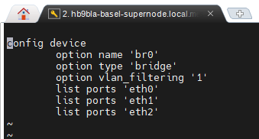

vi /etc/aredn_include/lan.network.user

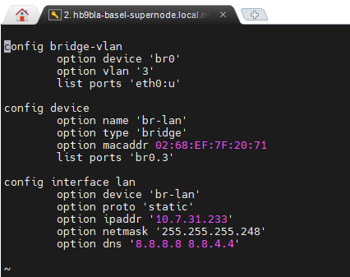

vi /etc/aredn_include/wan.network.user

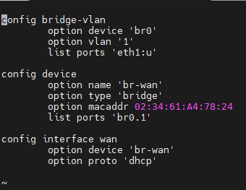

vi /etc/aredn_include/dtdlink.network.user

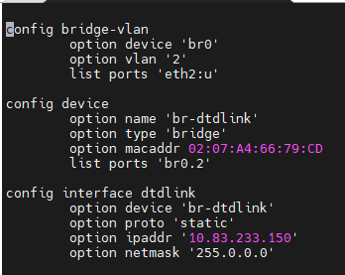

For a test you can type:

/usr/local/bin/node-setup -a mesh

And you should see the same config file as before. Also all tunnels should be up again.

Keep in mind that, if you change the network connection of your tunnel server in Proxmox, you have to delete all four files, reboot to create the right config, and recreate the four files with the copied content.

Now you can connect to localnode.local.mesh via browser and start to customize your server.

Give it the name: Callsign-VM-TUNNELSERVER (if not done before).

Connect it as a client to your Tunnel Server in the AREDN network. Make sure the administrator of your tunnel adjusts the name and the address of your new server. Maybe you want to run in parallel for a few days. After connecting to your Tunnel Server, you should see the other nodes in the net.

Now, you can add the tunnels you serve. Do not forget to forward port 5525 to the address of your Tunnel Server.

Ein Bild, das Text, Schrift, Software, Zahl enthält.

Finally, your Server should be connected to the SwissDigitalNet. Congratulations!

Ein Bild, das Text, Screenshot, Zahl, Webseite enthält.

## Backup of the VM

Backup machine to the local directory

Ein Bild, das Text, Screenshot, Software, Zahl enthält.

You find this directory

cd /var/lib/vz/dump/

on the Proxmox server. It can be saved to the local disk using WinSCP

## Install QUEMU Agent

This step is needed to control (e.g. shut down) the AREDN VM from Proxmox

You have to be connected to the SwissDigitalNet for this task

In your Management Console, you go to mesh status and select HB9EDI’s filerepo:

Ein Bild, das Text, Screenshot, Schrift, Zahl enthält.

And copy this link (right mouse click):

Ein Bild, das Text, Elektronik, Screenshot, Software enthält.

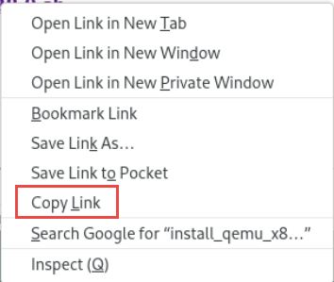

Now you paste the link into your terminal and add the yellow command

curl http://hb9edi-vm-gw.local.mesh/filerepo/install_qemu_x86_agents_3.28.0.sh |ash

Finally, you enable Guest Agent and reboot the machine

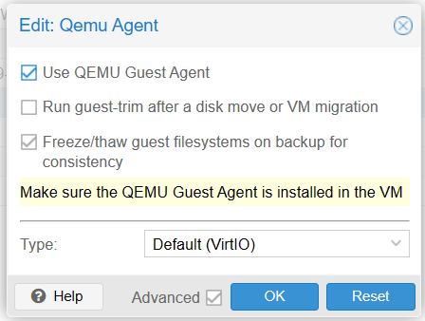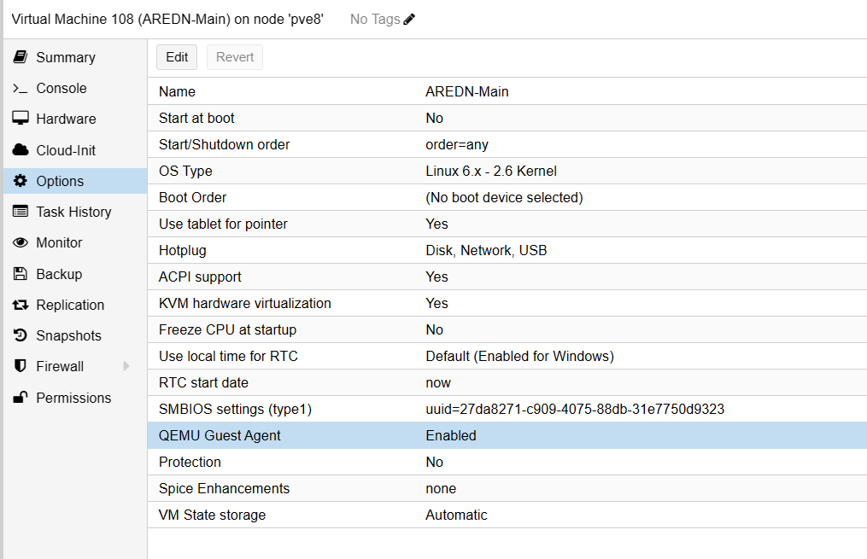

Now your Tunnel Server can be controlled by Proxmox.

#### Without connection to the SwissDigitalNet

Download and install these packets from

https://downloads.openwrt.org/releases/23.05.0/packages/x86_64/

/22.03.5/packages/x86_64/packages/libattr_2.5.1-1_x86_64.ipk

/22.03.5/packages/x86_64/packages/libffi_3.4.2-2_x86_64.ipk

/22.03.5/packages/x86_64/base/libpcre_8.45-3_x86_64.ipk

/22.03.5/packages/x86_64/packages/glib2_2.70.5-4_x86_64.ipk

/22.03.5/packages/x86_64/packages/virtio-console-helper_6.2.0-2_x86_64.ipk

22.03.5/packages/x86_64/packages/libevdev_1.13.0-1_x86_64.ipk

/22.03.5/packages/x86_64/packages/libudev-zero_1.0.1-1_x86_64.ipk

/22.03.5/packages/x86_64/packages/libstdcpp6_11.2.0-4_x86_64.ipk

/22.03.5/packages/x86_64/packages/qemu-ga_6.2.0-2_x86_64.ipk

If you do not find libstdcpp6_11.2.0-4_x86_64.ipk, download and install it from

<https://github.com/dhamstack/AREDNstack/blob/main/Firmware%20Repo/Proxmox/libstdcpp6_11.2.0-4_x86_64.ipk>

You can integrate all files into one file with the name install_qemu_x86_agents_3.28.0.sh.

#!/bin/ash

opkg install http://YourServer/packages/x86_64/packages/libattr_2.5.1-1_x86_64.ipk

opkg install http://YourServer/packages/x86_64/packages/libffi_3.4.2-2_x86_64.ipk

opkg install http://YourServer/packages/x86_64/base/libpcre_8.45-3_x86_64.ipk

opkg install http://YourServer/packages/x86_64/packages/glib2_2.70.5-4_x86_64.ipk

opkg install http://YourServer/packages/x86_64/packages/virtio-console-helper_6.2.0-2_x86_64.ipk

opkg install http://YourServer/packages/x86_64/packages/libevdev_1.13.0-1_x86_64.ipk

opkg install http://YourServer/packages/x86_64/packages/libudev-zero_1.0.1-1_x86_64.ipk

opkg install http://YourServer/packages/x86_64/libstdcpp6_11.2.0-4_x86_64.ipk

opkg install http://YourServer/packages/x86_64/packages/qemu-ga_6.2.0-2_x86_64.ipk

# Upgrade Tunnelserver

After upgrade, you will lose the network configuration. So it has to be added.

Ssh into the node:

ssh -l root -p 2222 localnode

Go on with editing the network config:

vi /etc/config/network

Instructions here: Configure the AREDN Tunnel Server

Make sure you still have the same IP address assigned (because of port forewarding)

# AREDN Virtual Machine as a Telephone Server

## Overview



## Setup

We create a new VM in addition to the Tunnel Server. If you do not operate a Tunnel Server, you just create a VM for your Telephone Server.

Do not copy the VM of the Tunnel Server.

The basis setup has to be done the same way as for the Tunnel Server. The main difference is that we chose VLAN10 as the management connection:

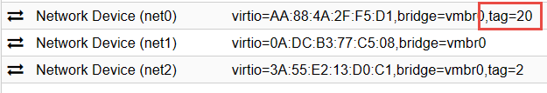

And we have to change the network of the Management Console, too:

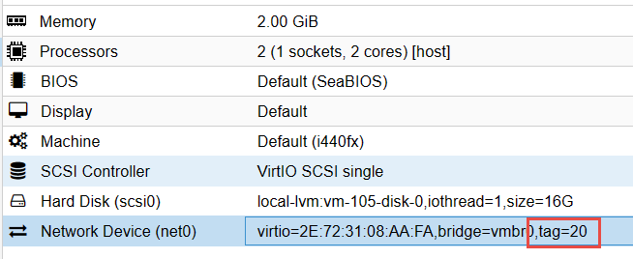

Do not assign the same VLAN to two AREDN management connections (you will get two concurrent DHCP servers)!

Now we should be able to manage the Telephone Server from the Management Console.

Maybe you have to reassign a new IP to the Management Console:

sudo dhclient -r

sudo dhclient

We can connect our phones to our home network instead of the hap router and they should get a normal address in the 192.168.xxx.xxx range.

Because our LAN of the VM is on VLAN 20, we must change the VLAN of the phone, too. We login and go to Network🡪 Advanced and enable VLAN 20.

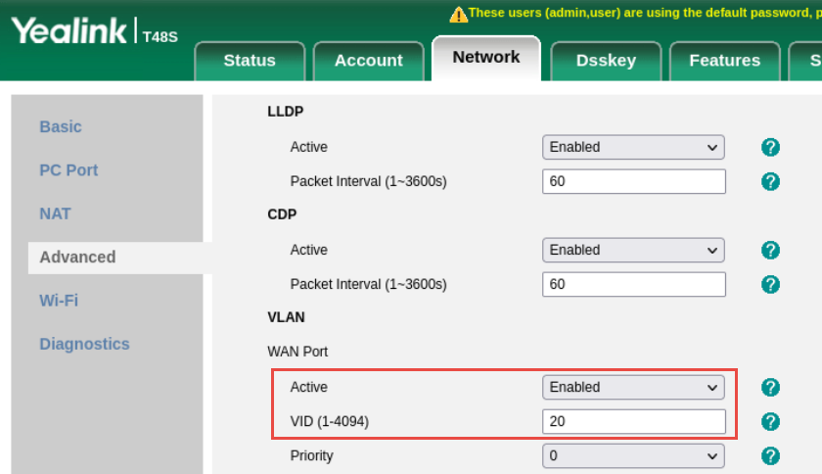

Now your phone should get a 10.xx.xx.xx address (instead of a 192.168.xxx.xxx) and you can install the phonebook and the SIP server as in every hap router and make the first test call.

The Tunnel Server VM and the telephone VM should be connected by a DtD link. You see this in the neighbour status:

Ein Bild, das Text, Screenshot, Schrift, Reihe enthält.

Be aware that you can only manage your VMs (other than the Tunnel Server) and phones from the Management Console. They are not connected to your home network.

You can shut the Management Console VM down if you do not need it if you do not have too much resources on your server.

## Final tip:

You can connect your Management Console to whatever AREDN VM you want (select VLAN 10 for the Tunnel and VLAN20 for the Telephone Server). From there, you can reach all your devices without changing the VLAN of the Management Console.